13.72:
This is the effective force constant of the two springs.
a) After the gravel sack falls off, the remaining mass attached to the springs is 225 kg. The force constant of the springs is unaffected, so 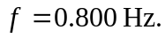
To find the new amplitude use energy considerations to find the distance downward that the beam travels after the gravel falls off.
Before the sack falls off, the amount that the spring is stretched at equilibrium is given by The maximum upward displacement of the beam is  above this point, so at this point the spring is stretched 0.2895 m.

With the new mass, the mass 225 kg of the beam alone, at equilibrium the spring is stretched The new amplitude is therefore 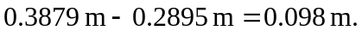The beam moves 0.098 m above and below the new equilibrium position. Energy calculations show that 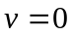when the beam is 0.098 m above and below the equilibrium point.
b) The remaining mass and the spring constant is the same in part (a), so the new frequency is again 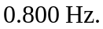
The sack falls off when the spring is stretched 0.6895 m. And the speed of the beam at this point is . Take  at this point. The total energy of the beam at this point, just after the sack falls off, is Let this be point 1. Let point 2 be where the beam has moved upward a distance d and where . 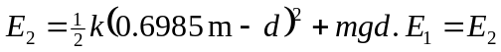 gives 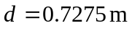. At this end point of motion the spring is compressed 0.7275 m – 0.6895 m =0.0380 m. At the new equilibrium position the spring is stretched 0.3879 m, so the new amplitude is 0.3789 m + 0.0380 m = 0.426 m. Energy calculations show that is also zero when the beam is 0.426 m below the equilibrium position.

